Swinburne University of Technology

Programming Concepts OnCampus Sem1 2019

Doubtfire Submission

**Task 5.13P**

*Submitted By:*

Sanduni Amanda Galhenage *Tutor:*

101337547 Somkiat Kitjongthawonkul

2019/05/21 11:11

May 21, 2019



Produced by Doubtfire

W5C2.html

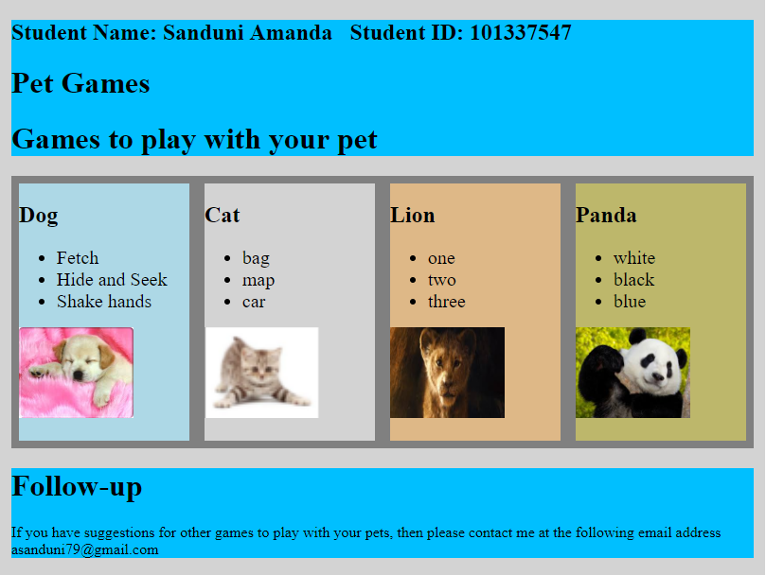

Content of w5C2.html

====================================================

<!DOCTYPE html>

<html lang="en">

<head>

<meta charset="utf-8" />

<meta name="description" content="Provide description" />

<meta name="Melbourne, Canberra, Sydney" content="australiancities" />

<meta name="Sanduni" content="Sanduni" />

<title>australian cities</title>

</head>

<link rel="stylesheet" href="w5C2.css">

<body>

<div class="container">

<header>

<h2>Student Name: Sanduni Amanda &nbsp; Student ID: 101337547</h2>

<h1>Pet Games</h1>

<h1>Games to play with your pet</h1>

</header>

<article class="middle-container">

<article class="flex-container">

<section class="flex-item">

<h2>Dog</h2>

<ul>

<li>Fetch</li>

<li>Hide and Seek</li>

<li>Shake hands</li>

</ul>

<img src="dog.png">

</section>

<section class="flex-item">

<h2>Cat</h2>

<ul>

<li>bag</li>

<li>map</li>

<li>car</li>

</ul>

<img src="cat.png">

</section>

<section class="flex-item">

<h2>Lion</h2>

<ul>

<li>one</li>

<li>two</li>

<li>three</li>

</ul>

<img src="lion.png">

</section>

<section class="flex-item">

<h2>Panda</h2>

<ul>

<li>white</li>

<li>black</li>

<li>blue</li>

</ul>

<img src="panda.png">

</section>

</article>

</article>

<footer>

<h1>Follow-up</h1>

<p>

If you have suggestions for other games to play with your pets, then please contact me at the following email address <br> asanduni79@gmail.com

</p>

</footer>

</div>

</body>

</html>

=================================================

Content of w5C2.css

.container{

background-color: #d3d3d3;

padding: 2px;

margin: auto;

margin-top: 30px;

}

@media screen and (min-width: 820px) {

.container{

width: 804px;

}

}

.middle-container{

margin: 10px;

}

.flex-container{

background-color: #808080;

}

.flex-container:after {

content: "";

display: table;

clear: both;

margin: 10px;

}

.flex-item {

float: left;

margin: 1%;

padding-bottom: 20px;

width: 23%;

background-color: #f1f1f1;

}

@media screen and (max-width: 720px) {

.flex-item {

margin: 2%;

width: 46%;

}

}

@media screen and (max-width: 400px) {

.flex-item {

margin: 2%;

width: 98%;

}

}

header{

background-color: #00bfff;

margin: 10px;

}

footer{

background-color: #00bfff;

margin: 10px;

}

li{

font-size: 20px;

}

.flex-item:nth-of-type(1){

background-color: #add8e6;

}

.flex-item:nth-of-type(2){

background-color: #d3d3d3;

}

.flex-item:nth-of-type(3){

background-color: #deb887;

}

.flex-item:nth-of-type(4){

background-color: #bdb76b;

}

img {

display: inline;

width: 121px;

height: 96px;

}

================================================